Technical material specifications – Need to knows

As we strongly believe that you as the customer are looking for a durable product that will add value to your property, we bring to your attention that our prices quoted are based on the following:
Concerning palisade fencing and unless your project has specific requirements, we quote as a rule on the option that we see as best suited for the project in question than on the cheapest option but the final decision rest with you the customer and your needs.
We will thus in conjunction with you discuss the necessary.
- For our product range, we use 2mm minimum thick steel and not 1.6mm as do most of our opposition.
- It is important to keep in mind that if a thinner steel is used, it cannot support the same span measurement with the same stiffness as that of the thicker steel.
- Palisade fencing can be supplied in both a painted and Galvanised finish. Galvanised coatings are specified in a wide range of coating mass categories. The thickness of the galvanising, is mostly depended on the thickness of the material
Requirements for coating thickness and mass for material/articles that are not centrifuged are mainly as follows.

Article thickness  (mm) | Local coating thickness  (μm) | Average coating thickness  (μm) | Average coating mass  (g/m2)
1.5 mm or less | 35 | 45 | 320
Over 1.5 to 3 mm | 45 | 55 | 390
Over 3 to 6 mm | 55 | 70 | 500
Over 6 mm | 70 | 85 | 600
- The posts and panels for the welded type product range are “hot-dip” galvanised while the palisade palings for the bolted panels are manufactured from Z275 lock forming quality pre-galvanised material in a standard thickness of 2mm. The Z prefix in the coating designation indicates the zinc coating while the number denotes the total mass of the zinc coating deposited to surface of the steel in grams per square meter (g/m²). The difference between the cold- and hot rolled products are mainly that with the hot rolled process a thicker galvanising finish can normally be achieved as listed in the table above. The galvanising thickness influences the ability to resist rust from taking place and subsequently the life of the product.
- The visual difference between Cold and hot rolled steel is illustrated in the below figure.
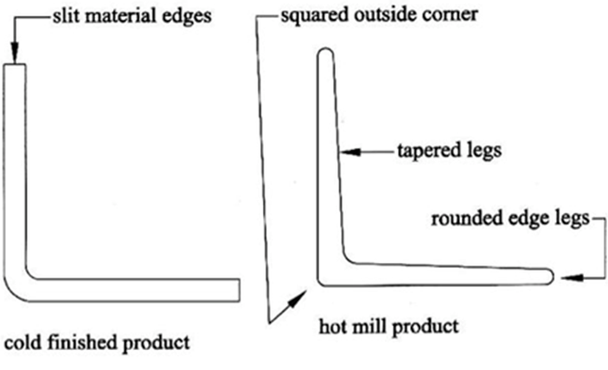
- We do not use existing and second-hand steel but only new material.
- We offer a bolt-on product range that is a practical solution to many applications especially where a galvanised option is preferred but where that added strength is a greater requirement, we suggest the slotted channel product range illustrated in the below picture. Picture as a courtesy from our material supplier.
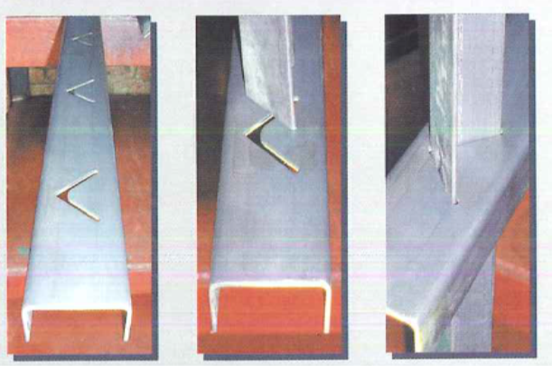
We believe that as the customer, it is in your best interest to consider the above when evaluating your project. For a more in-depth approach to material specifications visit our web-site at http://www.ap-carportsandfencing.co.za Also go to the testimonial page to see what our existing customers have to say about as.
The AP Carports and Fencing PTY Ltd. team aim to build long-term relationships based on quality and customer satisfaction.
Thank you for your support.

